**Carrom**

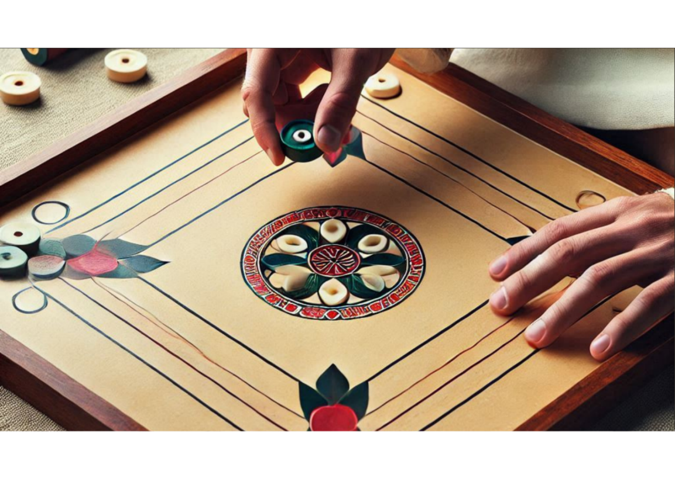

**Description:** A board game played on a square board with pockets in each corner. It combines elements of billiards and shuffleboard.

**How to Play:** Players use a striker to flick pieces into the pockets, aiming to score points.

**Location:** Indoor

**Things Needed:** Carrom board, striker, carrom men, powder

**Number of Players:** 2 to 4